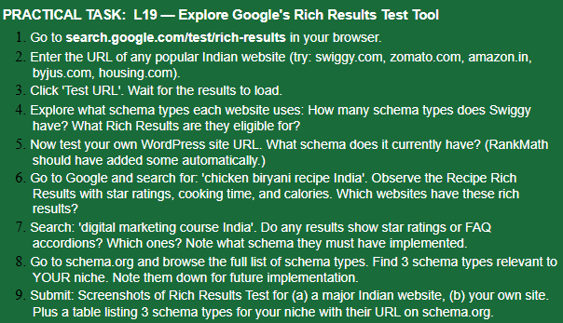
ANSWER:-
- Went to rich result.
- Entered Zomato.com.
- Clicked Test URL.
- 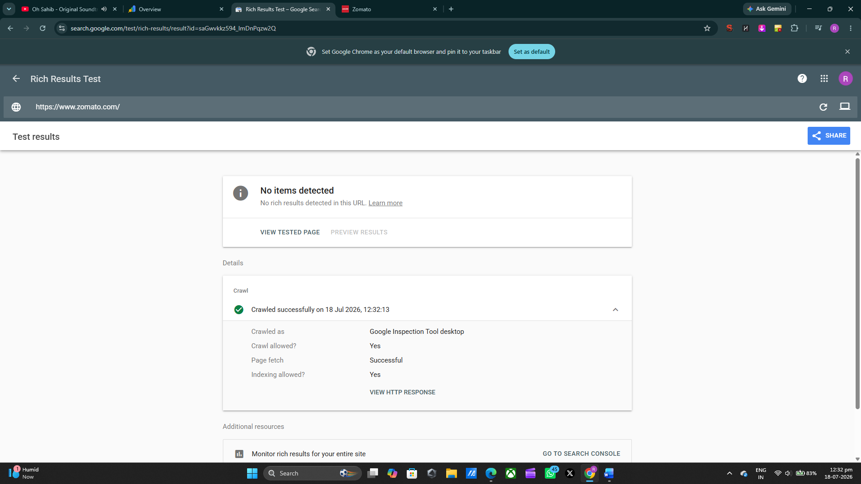This is the result.
- It is not showing any schema in Rich result.

Chicken Biryani Recipe


Swasthi's Recipes
https://www.indianhealthyrecipes.com › chicken-biryani-...

- 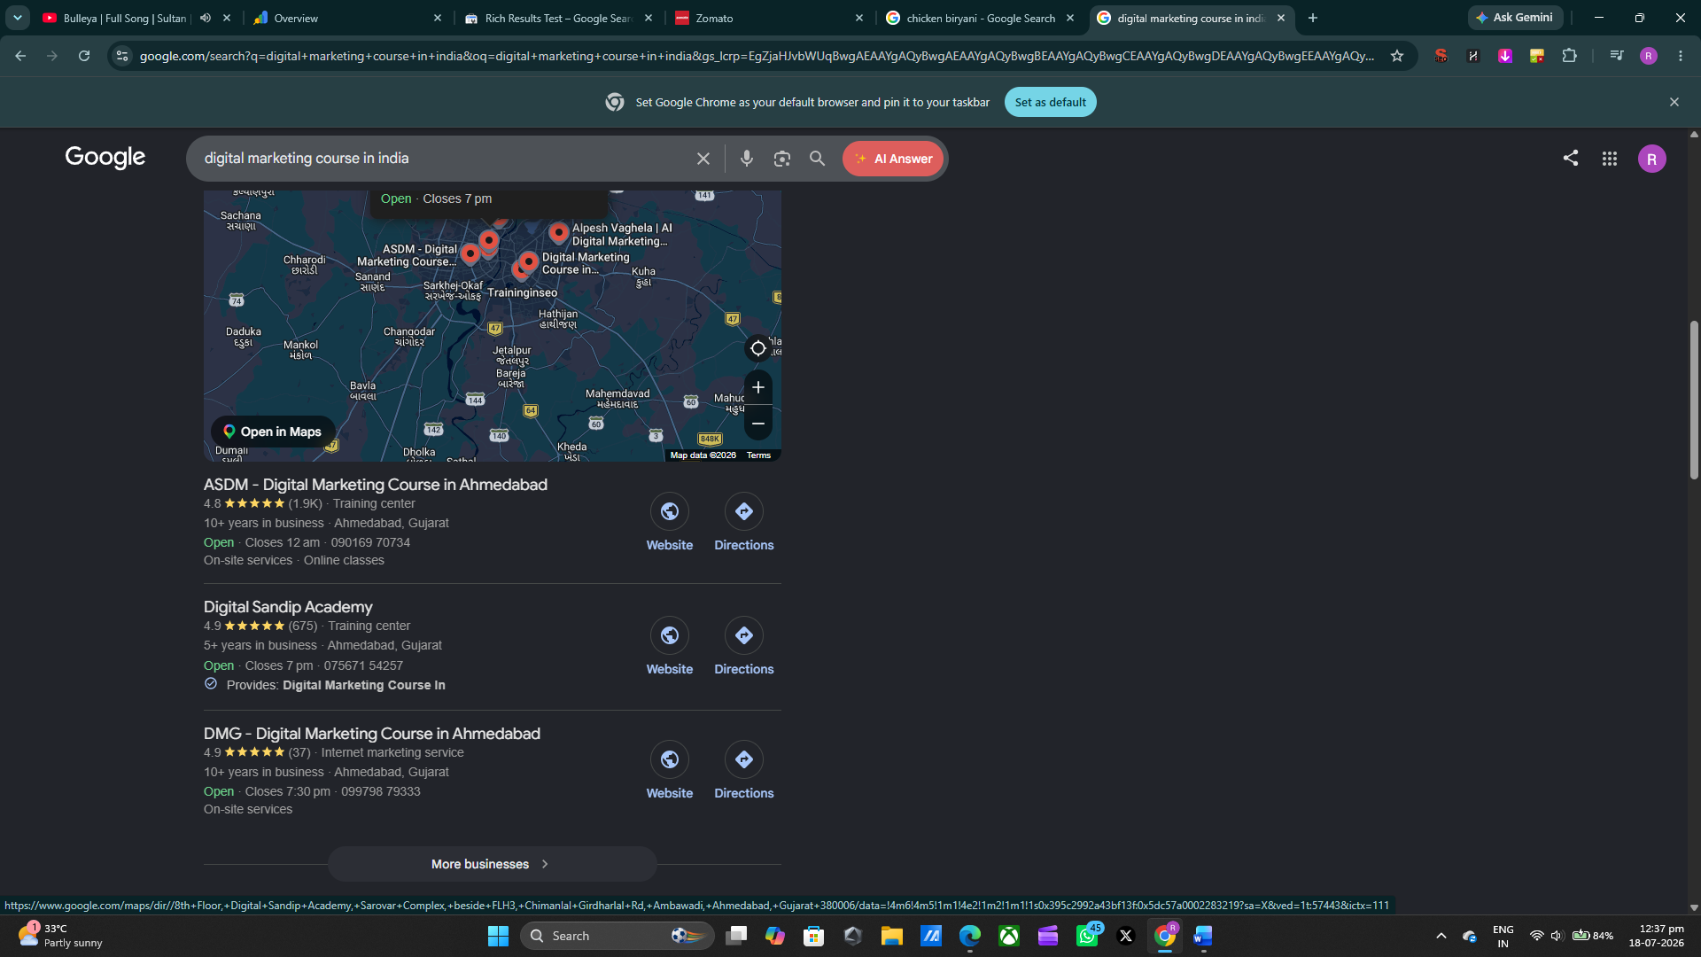They are using star-rating schema
- My niche is news and in that we have
Article schema
FAQs
ImageObject
- FAQs and ImageObject schema are there in every blog because FAQs is there cause of Frequently asked questions and ImageObject is there cause of it there with every image.
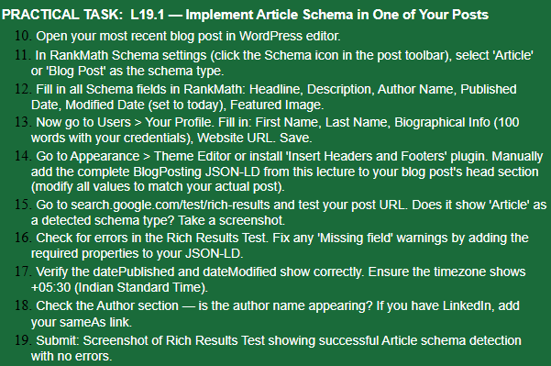
ANSWER:-
19. This is the result of our recent blog
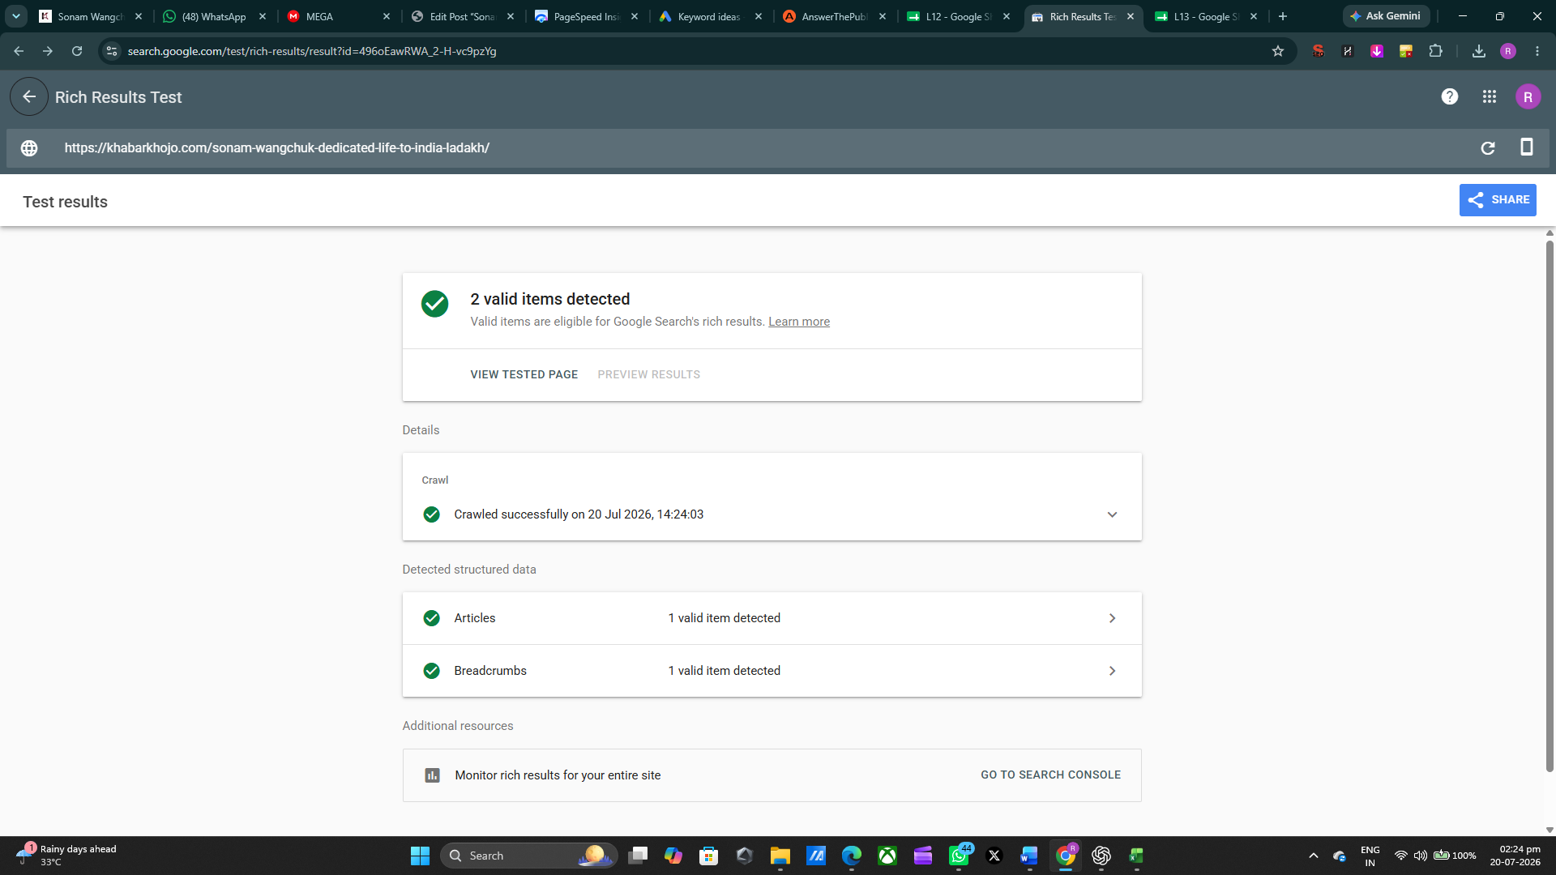

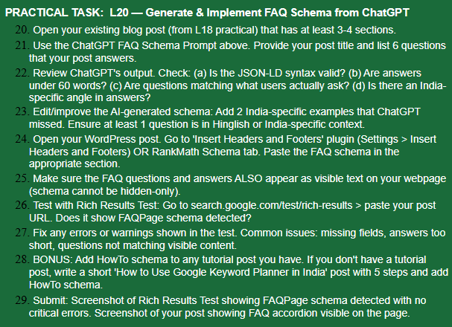
ANSWER:-
The FAQ questions and answers were added visibly to the article and FAQ structured data was implemented. Google Rich Results Test successfully detected the page's Article and Breadcrumb structured data. FAQ rich results are no longer generally available for news websites because Google discontinued the FAQ rich-result feature for general sites in 2026.
YET HERE’S THE PROOF THAT FAQs SECTION EXIST
